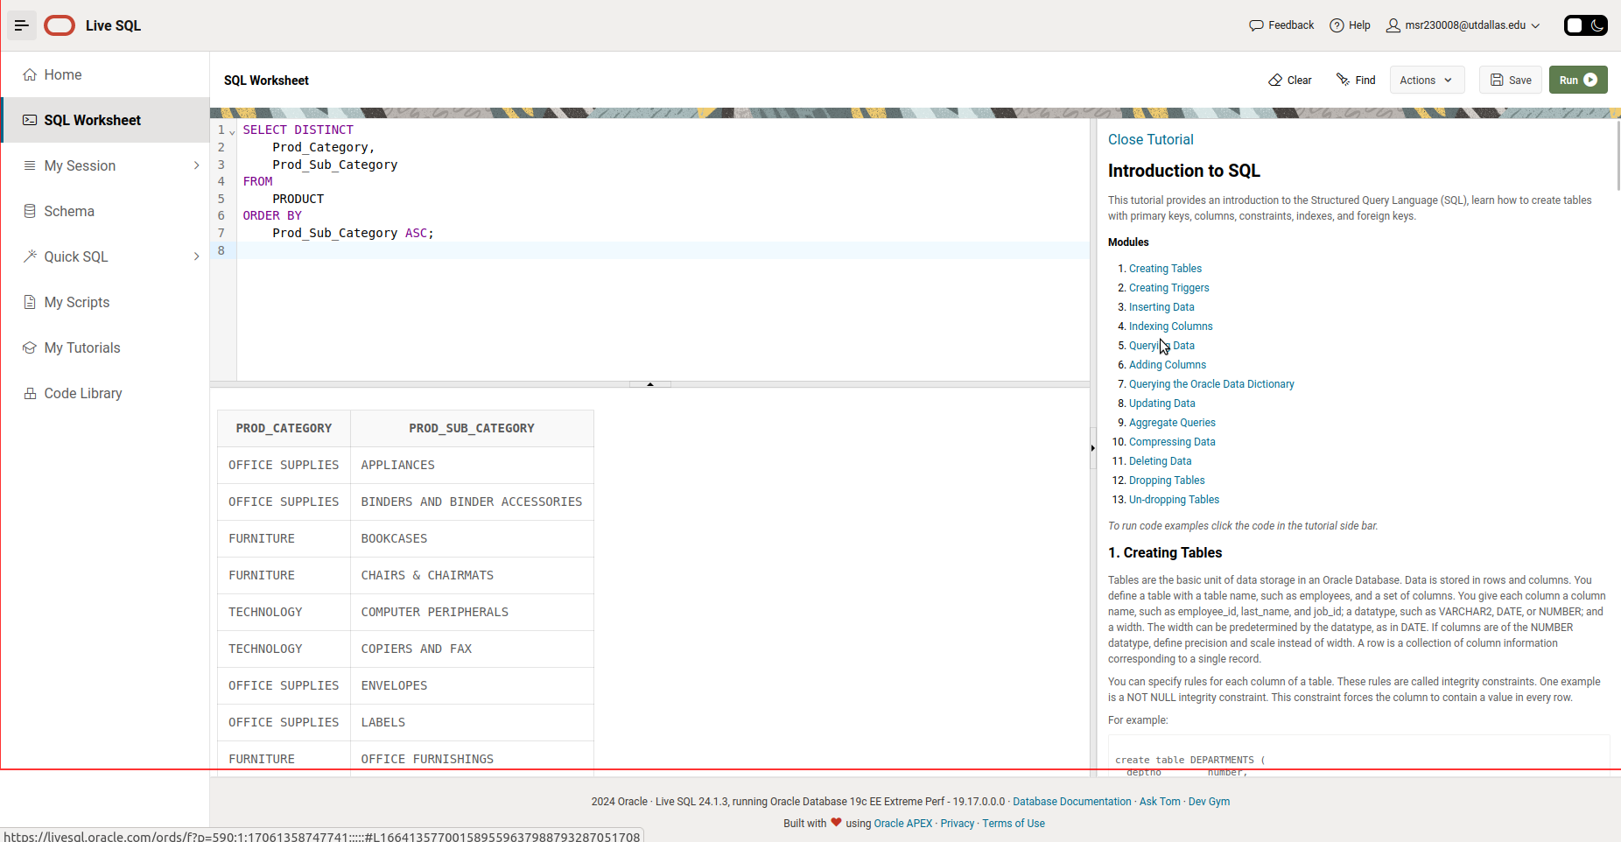

/*

1) Retrieves a unique list of product categories and subcategories from the PRODUCT table,

sorted in ascending order by subcategory, ensuring no duplicate combinations of

Prod_Category and Prod_Sub_Category

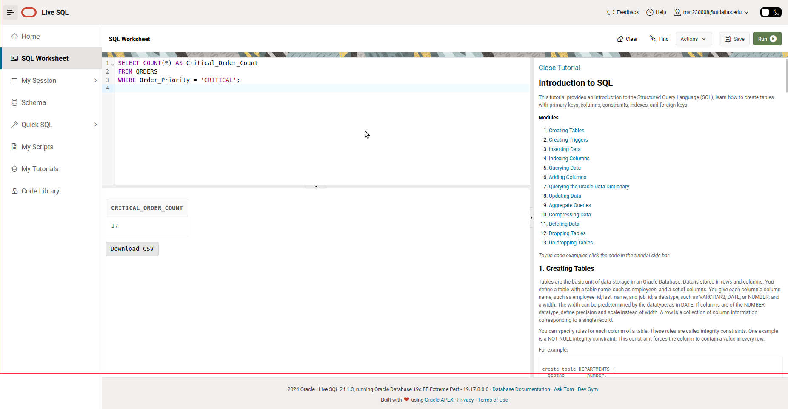

/*

2) Counts the total number of orders in the ORDERS table where the order priority is set to "CRITICAL."

*/

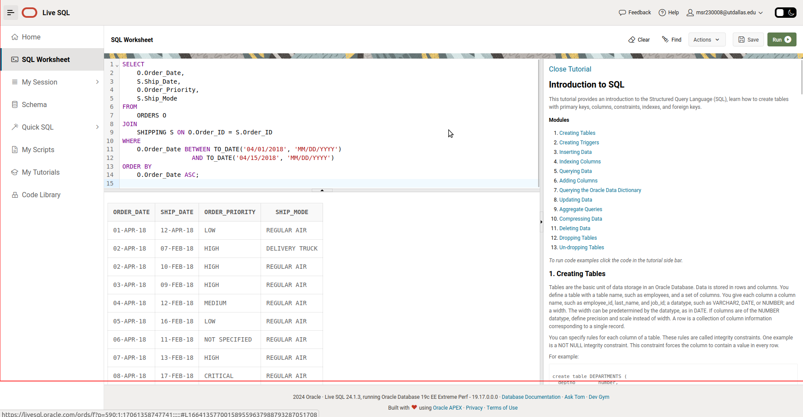

/*

3) Retrieves the order date, ship date, order priority, and ship mode for all orders placed between April 1, 2018, and April 15, 2018.

Joins the ORDERS and SHIPPING tables on Order_ID and sorts the results by order date in ascending order.

*/

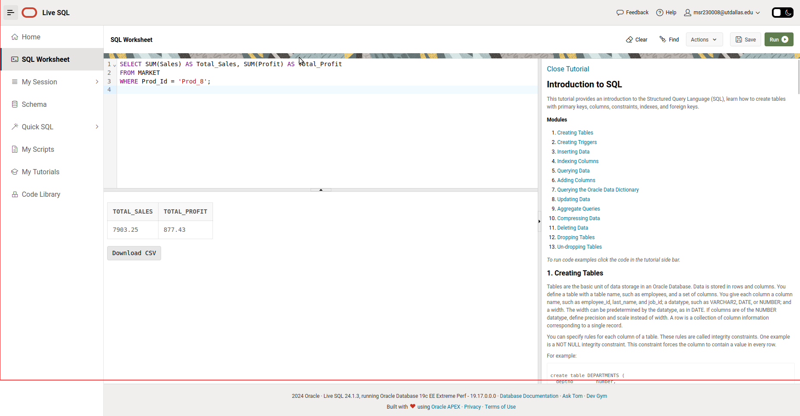

4)Calculates the total sales and total profit for the product with ID 'Prod_8' from the MARKET table.

Sums the Sales and Profit columns for all records corresponding to 'Prod_8'.

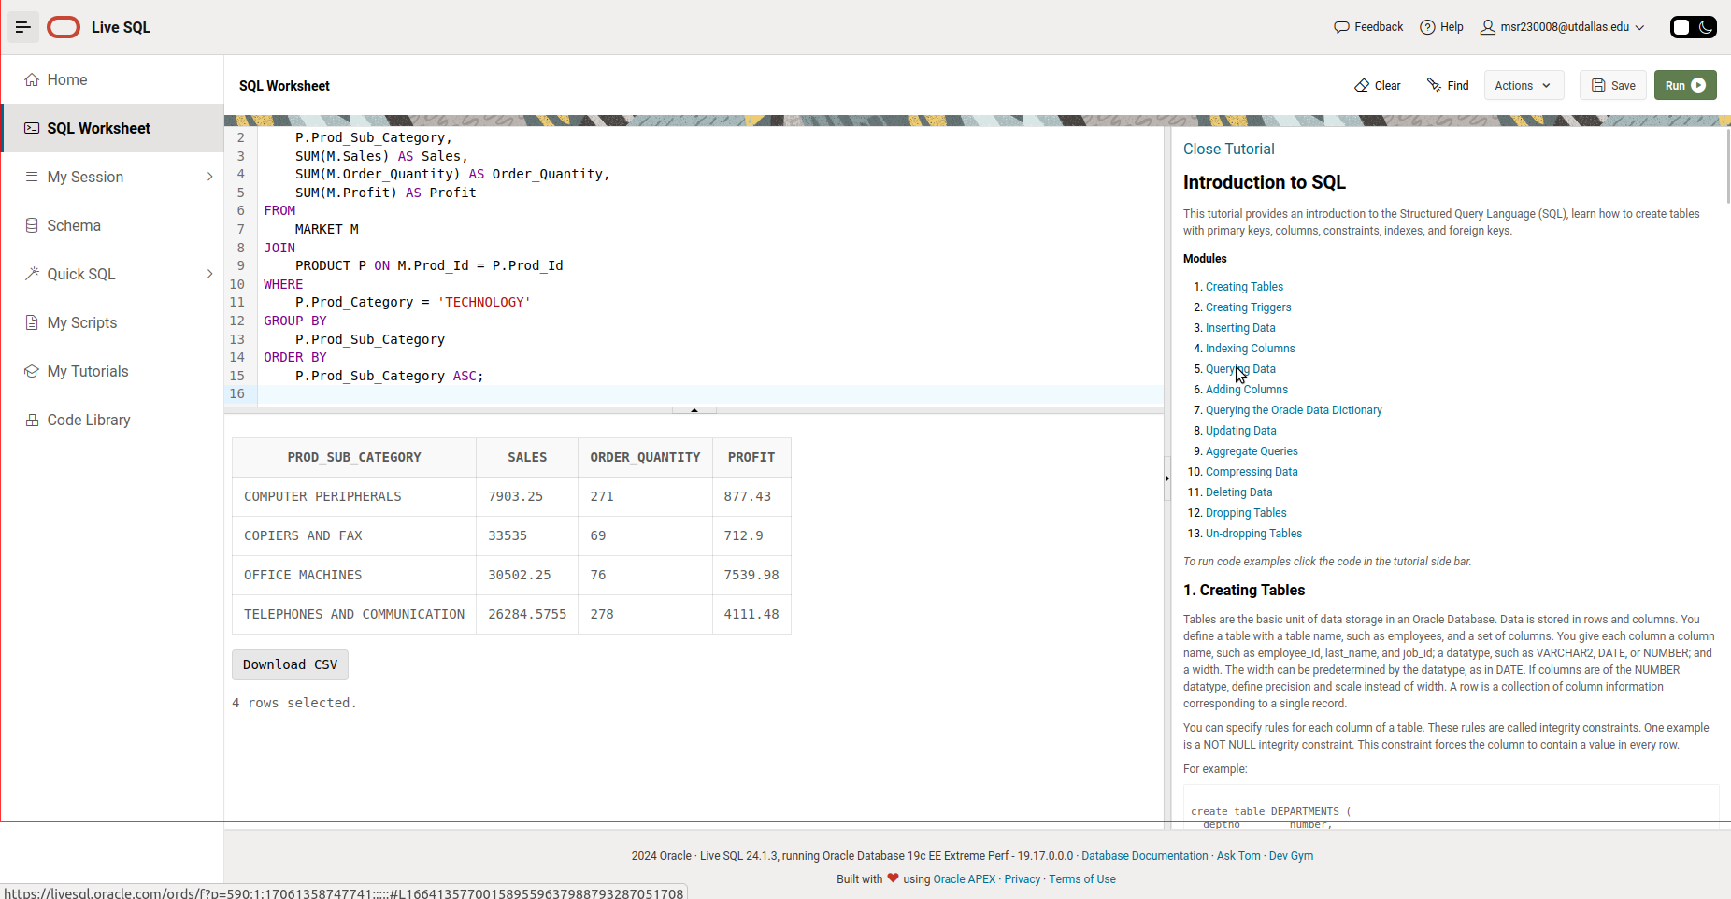

/*

5)Retrieves the total sales, total order quantity, and total profit for each product subcategory within the "TECHNOLOGY" category.

Joins the MARKET and PRODUCT tables using Prod_Id, groups the results by Prod_Sub_Category, and orders them alphabetically by subcategory.

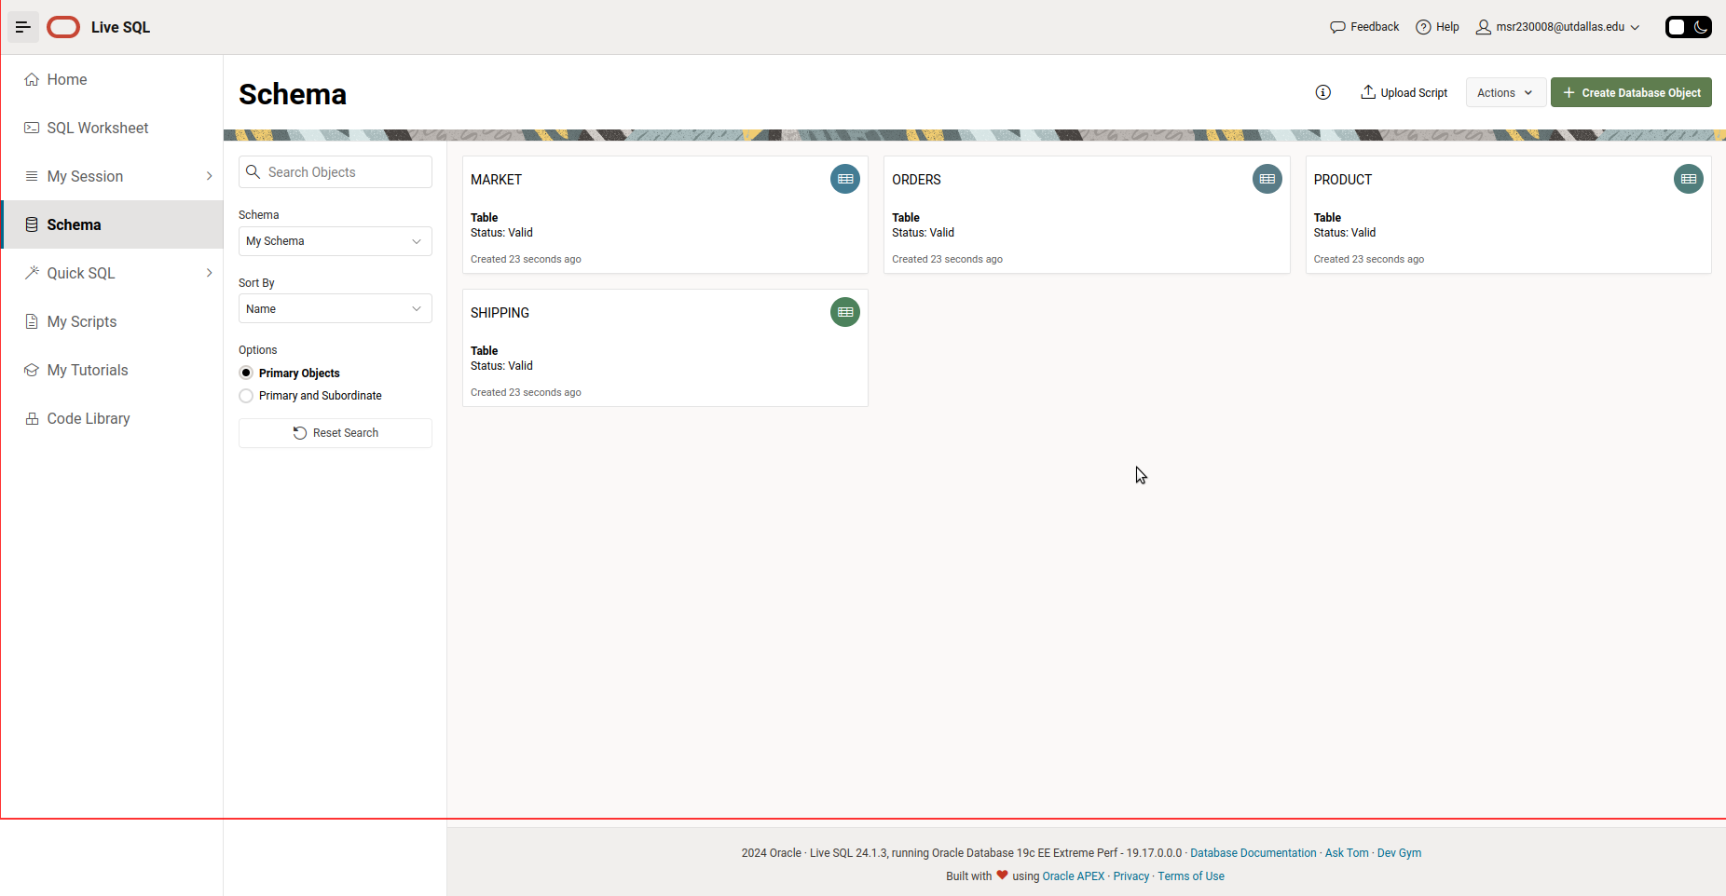

*" On my honor, I pledge that this is my own work. I have neither received nor given help to anyone else."*